**Senegal country profile**

Published

14 May 2018

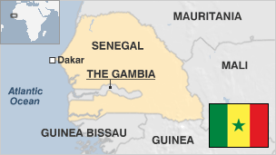

**Long considered one of Africa's model democracies, the western African nation of Senegal has a tradition of stable governments and civilian rule.**

Hundreds of Senegalese were killed in a local separatist conflict in the southern region of Casamance, but violence has waned since a 2014 ceasefire.

The country's stability has allowed it to send peacekeeping troops to DR Congo, Liberia and Kosovo.

Slaves, ivory and gold were exported from the coast during the 17th and 18th centuries and now the economy is based mainly on agriculture. The money sent home by Senegalese living abroad is a key source of revenue.

* Read more country profiles by [BBC Monitoring](http://bbc.co.uk/monitoring)

**President: Macky Sall**

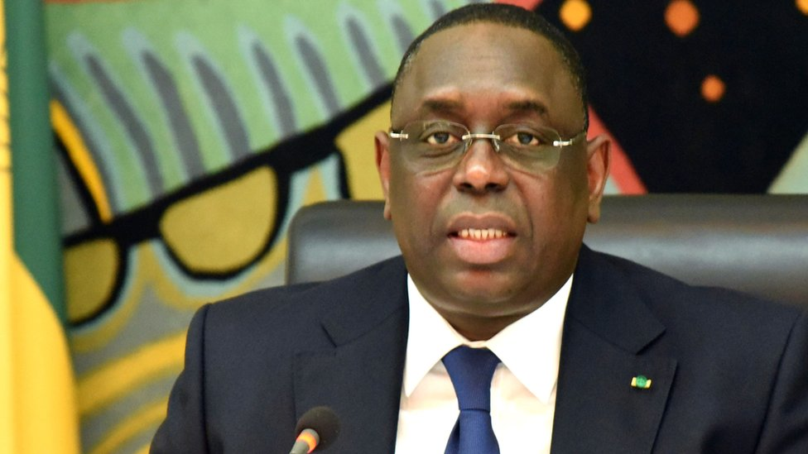image copyrightGetty Images

Once an ally of former President Abdoulaye Wade, Macky Sall created his own opposition party in 2008 and defeated Wade in the 2012 elections.

During his time in office, the separatist conflict in the southern Casamance region has waned, and in 2014 rebel leader Salif Sadio declared a unilateral ceasefire.

Mr Sall proposed reducing the presidential term from seven years to five, saying he wanted to set an example within Africa, where many leaders cling to power beyond their allotted term. The proposal won approval in a March 2016 referendum but will only be implemented after Mr Sall's term.

Senegal has a lively political scene, with parties competing across ethnic, religious and ideological lines.

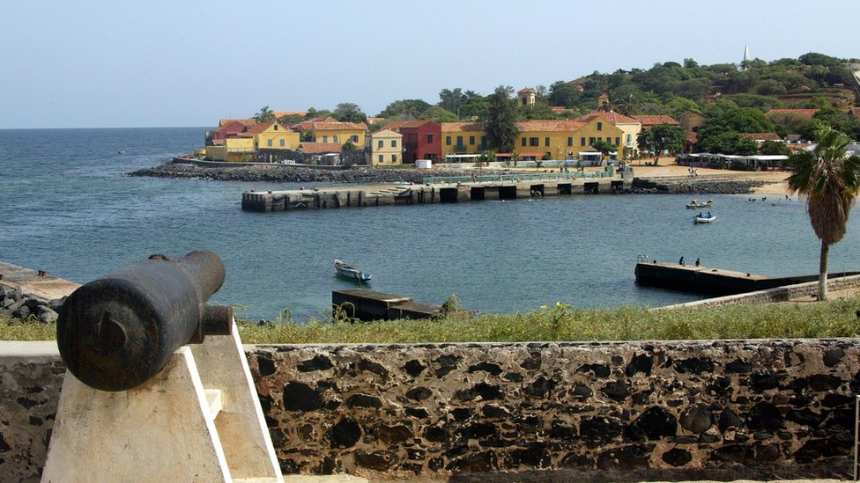image copyrightGetty Images

image captionThe Senegalese island of Goree was the largest slave-trading centre on the African coast

Senegal has traditionally had one of the most unrestricted and diverse media scenes in the region.

The constitution guarantees freedom of information and abuses against journalists are relatively infrequent, says press freedom group Reporters Without Borders.

# Senegal profile - Timeline

Published

14 May 2018

**A chronology of key events:**

**8th century** - Present-day Senegal is part of the Kingdom of Ghana.

**11th century** - Tukulor people occupy lower Senegal valley.

**12-14th centuries** - Rise of the Jolof empire.

**1440s** - Portuguese traders reach Senegal river estuary.

**1588** - Dutch establish slave port on island of Goree.

**1659** - French found St-Louis at the mouth of the Senegal river; it becomes a key slave-trading port.

**1677** - French take over island of Goree from the Dutch.

**1756-63** - Seven Years' War: Britain takes over French posts in Senegal, forms colony of Senegambia. France regains its holdings during American Revolutionary War of 1775-83.

**1816** - Britain returns French holdings captured during Napoleonic Wars.

**Late 1800s** - France extends its influence, gains control of all the territory of Senegal.

**1895** - Senegal becomes part of French West Africa.

**1914** - Blaise Diagne elected as Senegal's first African deputy to French parliament.

**1946** - Senegal becomes part of the French Union.

**1956** - National Assembly established.

**1958** - Becomes an autonomous republic, as part of the French Community.

## Independence

**1960** June - Senegal becomes independent, as part of Mali Federation.

**1960** August - Senegal pulls out of Mali Federation, becomes separate republic with Leopold Senghor as president.

**1962** - Attempted coup led by Prime Minister Mamadou Dia.

**1963** - First constitution drawn-up.

**1966** - Senghor's Senegalese Progressive Union becomes country's sole political party.

**1978** - Three-party political system introduced.

**1981** - Leopold Senghor steps down; Abdou Diouf becomes president in 1981.

**1982** - Senegambian Confederation formed; Senegal and neighbouring Gambia aim to combine military and security forces. Dissolved in 1989.

**1982** - Separatists in southern province of Casamance form Casamance Movement of Democratic Forces.

## Political change

**2000** March - Opposition leader Abdoulaye Wade wins second round of presidential elections, ending 40 years of Socialist Party rule.

**2001** January - Voters back new constitution which shortens presidential term, limits holder to two terms, and gives president power to dissolve parliament.

**2001** March - Government signs peace accord with separatist rebels in Casamance. But there is little follow-up as separatists go through splits and leadership changes.

**2001** April - Abdoulaye Wade's Senegalese Democratic Party wins an overwhelming majority in parliamentary elections.

**2004** December - Casamance Movement of Democratic Forces and government sign pact aimed at ending secessionist struggle in province of Casamance.

## Tariff row

**2005** October - Dispute with neighbouring Gambia over ferry tariffs on the border leads to a transport blockade. The economies of both countries suffer. Nigerian President Olusegun Obasanjo brokers talks to resolve the issue.

**2006** August - The army launches an offensive against rebels from a holdout faction of the Casamance Movement of Democratic Forces.

**2006** December - Spain and Senegal agree a series of measures to curb illegal migration to the Canary Islands. Spain is to give 4,000 Senegalese temporary work permits over the next two years.

**2007** June - President Wade's ruling coalition increases its parliamentary majority in elections boycotted by the opposition.

## Habre trial moves

**2008** April - Senegal's national assembly amends the country's constitution to allow the trial of Chad's ex-leader Hissene Habre, who is accused of human rights abuses during his eight years in power.

**2009** March - Opposition parties win control of several cities in local elections, including Dakar, formerly a stronghold of President Wade.

**2009** April - Belgium starts proceedings at the International Court of Justice in The Hague to try to force Senegal to bring former Chadian President Hissene Habre to trial for alleged human rights abuses during his time in power.

**2009** May - UN court accepts Senegal's pledge to keep in Hissene Habre in the country ahead of trial for rights abuses.

**2009** September-October - Clashes between troops and rebels in the province of Casamance.

**2010** April - France gives up its military bases in the country.

## Change of leader

**2012** March - Macky Sall wins presidential elections, and his coalition wins July parliamentary elections.

**2012** September - MPs abolish the upper house, the Senate, and the post of vice president in an effort to save money for flood relief. Critics say the aim is to weaken the opposition.

**2013** July - The Senegalese authorities arrest former Chadian President Hissene Habre in Dakar and put him on trial him for crimes against humanity committed in Chad under his rule.

**2014** April - Rebel leader Salif Sadio, who had been fighting for the independence of the Casamance region, declares a unilateral ceasefire.

**2015** January - Senegal expels leading Gambian opposition figure Cheikh Sidya Bayo to France, accusing him of being a threat to public order.

**2015** March - Karim Wade, the son of former President Abdoulaye Wade, is jailed for six years for illicit enrichment while serving as a minister under his father, in what critics say is a politically motivated case. He is pardoned in June 2016 and leaves the country.

**2016** March - Voters in a referendum approve a proposal to reduce the presidential term from seven years to five.

**2016** May - Former leader of Chad Hissene Habre is found guilty of crimes against humanity and sentenced to life in prison by an African Union-backed court in Senegal.

**2016** October - France drops long-standing warning against travel to Casamance region, in a move likely to boost the important tourism sector.

**2017** January - Senegalese troops gather on Gambian border ready to enforce transfer of power under ECOWAS regional mandate after President Jammeh refuses to step down on losing presidential election.

**2017** April - Thousands protest in the capital Dakar against the president, demanding the release of several of his political opponents.

**2017** August - Parliamentary elections. President Sall's coalition wins more than two-thirds of the seats.

**2018** March - Khalifa Sall, the mayor of Dakar and potential rival of the current president in next year's election, is convicted and jailed for corruption.